A Research-Oriented Framework for Evaluating Synthetic NLP Datasets Using Fidelity, Diversity, and Downstream Utility
Raunak Singh Baweja and Om Nikam
NLP Evaluation Research Project
Abstract—This paper presents a research-oriented framework for evaluating synthetic natural language processing (NLP) datasets against their original counterparts. Rather than treating synthetic-data quality as a single similarity measure, the proposed system evaluates three complementary dimensions: fidelity, diversity, and downstream utility. Fidelity is assessed using dataset statistics, text-length characteristics, vocabulary and n-gram overlap, TF-IDF similarity, semantic similarity, and class-distribution alignment. Diversity is assessed using unique-text ratio, duplicate rate, vocabulary richness, and repetition indicators. Utility is measured through a controlled classification experiment in which a model trained on synthetic data is evaluated on the same held-out real test set used for the real-data baseline. The framework was implemented as a full-stack application with a React/TypeScript frontend, FastAPI backend, PostgreSQL experiment storage, and an NLP evaluation engine based on Python and scikit-learn, with sentence-embedding support. A Hindi three-class sentiment dataset was used for experimental evaluation. The evaluated original dataset contained 2,479 records and the synthetic dataset contained 2,480 records. The experiment produced a project-defined composite score of 53/100, with fidelity of 41%, diversity of 22%, and a normalized utility score of 100%. The raw downstream macro-F1 retention was approximately 120%. The results illustrate why downstream utility alone is insufficient: despite strong class-distribution alignment and high utility, the synthetic dataset exhibited very low vocabulary overlap and a substantially higher duplicate rate. The framework therefore provides a transparent and reproducible basis for comparing synthetic NLP datasets.
Index Terms—Synthetic data, NLP, dataset evaluation, text classification, fidelity, diversity, utility, sentiment analysis, TF-IDF, semantic similarity.

I. Introduction
Synthetic data is increasingly used to augment machine-learning datasets, reduce dependence on costly annotation, and support privacy-aware development. In NLP, however, a synthetic corpus can appear plausible while still failing to reproduce the statistical and linguistic structure required by downstream models. Conversely, a dataset may obtain strong task performance while being overly repetitive or too close to the source distribution. This creates a need for evaluation procedures that separate different notions of quality rather than collapsing them into a single measure.
The practical appeal of synthetic text has grown rapidly with the arrival of large pretrained language models. Transformer architectures [1] and pretrained encoders such as BERT [2] made high-quality text representations widely available, while few-shot generative models [3] made it possible to produce entire labeled corpora from a handful of prompts. Generated training data is now common for classification and instruction tuning [4–6]. Earlier augmentation methods such as synonym replacement and back-translation [7, 8] showed that artificial examples can improve classifier accuracy, especially in low-resource settings.
This convenience introduces a methodological problem. When a synthetic dataset is used in place of, or alongside, real data, researchers must be able to state in what sense it is good. A corpus that faithfully copies the original may offer little novelty and may even leak sensitive training records [9]. A corpus that supports high accuracy may still be built from a few templates. Recent work emphasizes that synthetic-data quality is multidimensional, with quality, diversity, and downstream effects interacting in non-trivial ways [10], and that generated corpora frequently exhibit reduced diversity and systematic bias [11].
The problem is sharper for languages other than English. Most evaluation tooling, embedding models, and benchmarks are developed primarily for high-resource languages, whereas the majority of the world’s languages remain comparatively under-served [12]. Indian languages such as Hindi are written in the Devanagari script, are morphologically rich, and frequently appear in code-mixed form, so tokenization and lexical statistics behave differently from English. Resources such as IndicNLPSuite have begun to close this gap [13], and surveys of synthetic data for multilingual NLP highlight both the usefulness of generated examples and the difficulty of identifying unsuitable or low-quality instances [14]. These observations motivate a practical evaluation framework in which a real dataset and a synthetic dataset pass through the same analysis pipeline, with language-agnostic preprocessing and clearly documented metrics.
The objective of this work is therefore to design and implement a reusable NLP evaluation platform that answers a simple research question: how closely does a synthetic dataset reproduce the characteristics and usefulness of an original dataset? The proposed system evaluates three dimensions—fidelity, diversity, and utility—and reports both individual metrics and a transparent project-defined composite score. More specifically, the work addresses three sub-questions: (RQ1) does the synthetic corpus preserve the lexical, distributional, and semantic properties of the original corpus; (RQ2) does it contain sufficient internal variety, or is it dominated by duplicates and repeated phrases; and (RQ3) can a classifier trained only on synthetic data perform well on real held-out data?
The main contributions of this paper are as follows:
- A three-dimensional evaluation formulation that separates fidelity, diversity, and downstream utility, with every component metric defined by an explicit formula.
- A controlled Synthetic$→$Real versus Real$→$Real utility protocol in which both models are evaluated on the identical held-out original test split.
- A full-stack, reproducible implementation with dataset validation, aligned metric computation, experiment history, and CSV/JSON/PDF reporting.
- An experimental evaluation on a Hindi three-class sentiment corpus that demonstrates how high utility can coexist with poor lexical fidelity and diversity.

II. Related Work

A. Synthetic Data Generation for NLP
Synthetic text has been produced by rule-based augmentation, paraphrasing, and prompting of pretrained language models. Wei and Zou proposed simple edit-based operations for small classification datasets [7], and Feng et al. surveyed NLP augmentation more broadly [8]. Larger generators have been used to build complete datasets for zero-shot learning [4, 5] and to bootstrap instruction data [6]. These works concentrate on generation, and evaluation is usually limited to the accuracy of the target task.

B. Evaluation of Synthetic and Generated Data
Evaluation of synthetic data has traditionally considered statistical similarity and downstream predictive performance. Recent synthetic-text research argues for multi-dimensional evaluation that also covers distributional differences, diversity, fairness, and privacy risk [15]. Maximizing similarity to a reference corpus does not necessarily maximize useful novelty [10]. Alaa et al. proposed sample-level fidelity, diversity, and generalization metrics for generative models [16]. These measures target generation quality rather than auditing labeled training corpora, which is the focus here.

C. Lexical, Distributional, and Semantic Similarity
TF-IDF remains a simple and interpretable representation for comparing lexical characteristics and for baseline classifiers [17], usually combined with cosine similarity [18]. The Jaccard coefficient [19] gives a bounded measure of set overlap for vocabularies and n-gram inventories, and Jensen–Shannon divergence is a symmetric, bounded way to compare probability distributions [20]. For meaning beyond exact word overlap, Sentence-BERT produces sentence embeddings that can be compared with cosine similarity [21].

D. Diversity, Repetition, and Memorization
Lee et al. showed that deduplicating training data improves language models and reduces memorization [22], and Carlini et al. showed that models can reproduce verbatim training sequences [9]. Generated datasets are also prone to repetition and attribute bias [11], so we treat diversity as its own dimension.

E. Research Gap
Earlier studies either report only task accuracy for a generation method or propose single metrics without a workflow around them. Our contribution is not a new generator but an evaluation workflow that brings linguistic statistics, distributional similarity, diversity checks, and a controlled utility experiment into one reproducible application.

III. System Architecture
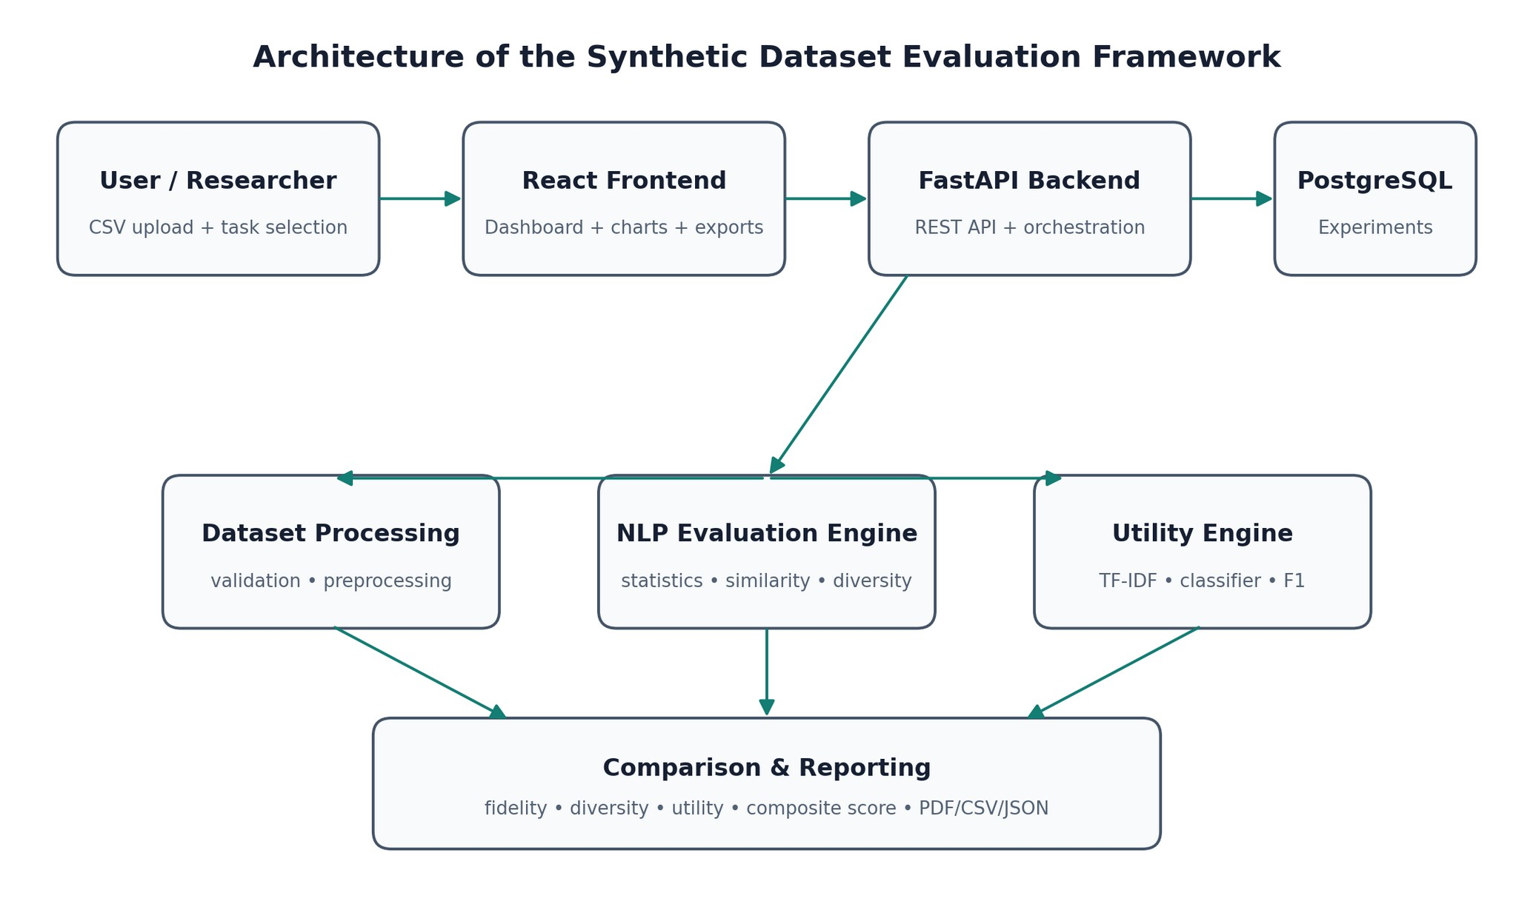
Fig. 1. System architecture of the proposed synthetic NLP dataset evaluation framework. The upper row shows the request path from the researcher to storage; the middle row shows the three analysis engines; the bottom block aggregates their outputs into scores and reports.
The framework follows a layered architecture. A researcher uploads an original CSV and a synthetic CSV through the web interface. The frontend communicates with a FastAPI backend, which validates the files, identifies text and label columns, executes the NLP evaluation pipeline, and persists experiment metadata and results. PostgreSQL stores dataset metadata, metric values, comparison records, and configuration information.
The evaluation engine is divided into dataset processing, linguistic evaluation, similarity/diversity analysis, and utility evaluation. The comparison layer then converts the two evaluation outputs into aligned metric pairs and computes differences or normalized similarity scores. Finally, the reporting layer presents an interactive dashboard and supports CSV, JSON, and PDF exports.

A. Detailed Explanation of the Architecture Diagram
Fig. 1 is organized into three horizontal tiers, and the arrows indicate the direction of data and control flow.
Tier 1 – Interaction and orchestration. The left-most block, User/Researcher, represents the person running an evaluation; their inputs are two CSV files and a task selection (text classification in the current version). The arrow into the React Frontend indicates that all interaction happens through a browser-based dashboard, which also renders charts and triggers exports. The next arrow represents REST calls from the frontend to the FastAPI Backend, which exposes endpoints for uploading datasets, creating comparisons, retrieving comparison details, and downloading reports. The backend validates requests, calls the analysis engines in order, and writes results to PostgreSQL: dataset records, evaluation runs, metric values, and the full configuration, so any experiment can be reopened from the history page and rerun.
Tier 2 – Analysis engines. The diagonal arrow from the backend to the NLP Evaluation Engine and the horizontal branches to its left and right show that one comparison request fans out into three cooperating components. Dataset Processing performs validation and preprocessing: it checks for missing values and duplicates, normalizes whitespace, and tokenizes text. The central NLP Evaluation Engine computes dataset statistics, similarity measures, and diversity indicators. The Utility Engine builds TF-IDF features, trains classifiers, and computes F1-based metrics.
Tier 3 – Aggregation and reporting. The three converging arrows into Comparison & Reporting indicate that the outputs of all engines are merged into aligned original-versus-synthetic metric pairs, grouped into fidelity, diversity, and utility, and combined into the composite score.
The architecture intentionally separates dataset-independent metrics from task-dependent metrics. General textual metrics can be reused across datasets, while utility metrics are selected according to the NLP task. The initial implementation targets text classification and is demonstrated with sentiment analysis.

IV. Methodology and Implementation
Notation: $D_{o}$ and $D_{s}$ denote the original and synthetic datasets, $n_{o}=\left|D_{o}\right|$ and $n_{s}=\left|D_{s}\right|$ their sizes, $V_{o}$ and $V_{s}$ their vocabularies, and $ϵ={10}^{−9}$ a small constant that prevents division by zero. All similarity values lie in $\left[0,1\right]$ and are multiplied by 100 when displayed as percentages.

A. Dataset Ingestion and Preprocessing
Dataset ingestion begins with CSV validation, missing-value inspection, duplicate detection, and user confirmation of the text and label columns. The same preprocessing configuration is applied to both datasets. Raw text is preserved for semantic analysis, while normalized/tokenized representations are used for lexical statistics.
Normalization collapses consecutive whitespace and trims each record. Tokenization is Unicode-aware: after lowercasing, a character is kept as part of a token when its Unicode general category is a letter (L), mark (M), or number (N). Retaining the mark category is essential for Devanagari, where vowel signs (matras) and the virama are combining marks; an ASCII-only tokenizer would split Hindi words into fragments. Stopwords are not removed by default so that informative task vocabulary is not discarded.

B. Dataset Statistics
For a dataset with documents $d_{1},…,d_{n}$, let $ℓ_{i}$ be the number of tokens in $d_{i}$ and N=i​ℓi the total token count. The mean text length and the type-token ratio (TTR) are
$μ=\frac{1}{n}\sum_{i=1}^{n}{ℓ_{i}}, TTR=\frac{\left|V\right|}{N}.$ (1)
Median, standard deviation, minimum, and maximum length, word-frequency tables, top unigrams and bigrams, and the class proportions $p\left(c\right)=n_{c}/n$ are also recorded.
For scalar statistics such as record count, mean length, vocabulary size, and TTR, the comparison layer converts the original value $a$ and synthetic value $b$ into a bounded similarity:
$S_{rel}\left(a,b\right)=max​\left(0, 1−\frac{\left|a−b\right|}{max\left(\left|a\right|,ϵ\right)}\right).$ (2)

C. Fidelity Metrics
1) Vocabulary and n-gram overlap. Vocabulary overlap is based on set intersection and union using the Jaccard coefficient [19]:
$J\left(A,B\right)=\frac{\left|A∩B\right|}{\left|A∪B\right|}.$ (3)
It is applied to the vocabularies ($S_{voc}=J\left(V_{o},V_{s}\right)$), to unigram sets ($S_{1g}$), and to the sets of distinct bigrams ($S_{2g}=J\left(G_{o}^{\left(2\right)},G_{s}^{\left(2\right)}\right)$).
2) TF-IDF similarity. A single vectorizer (unigrams and bigrams, up to 10,000 features) is fitted on the union of both corpora so that both share one feature space. The weight of term $t$ in document $d$ is
$w_{t,d}={tf}_{t,d}⋅\left(ln\frac{1+n}{1+{df}_{t}}+1\right),$ (4)
followed by $L_{2}$ normalization of each document vector [17, 18]. The dataset centroids ${\overset{‾}{x}}_{o}$ and ${\overset{‾}{x}}_{s}$ are the means of the document vectors, and the similarity is their cosine:
$S_{tfidf}=cos\left({\overset{‾}{x}}_{o},{\overset{‾}{x}}_{s}\right)=\frac{{\overset{‾}{x}}_{o}⋅{\overset{‾}{x}}_{s}}{∥{\overset{‾}{x}}_{o}∥ ∥{\overset{‾}{x}}_{s}∥}.$ (5)
3) Semantic similarity. A random sample (fixed seed) of each dataset is encoded with a sentence-embedding model [21] into $L_{2}$-normalized vectors $e_{i}$. The semantic similarity is the cosine between the embedding centroids,
Ssem=cos​1moi​eio, 1msj​ejs. (6)
If the embedding model is unavailable, the system falls back to the TF-IDF centroid similarity and records that fallback in the experiment configuration.
4) Class-distribution similarity. Let $P$ and $Q$ be the original and synthetic label distributions and $M=1/2\left(P+Q\right)$. The Jensen–Shannon divergence [20] with base-2 logarithms is
$JSD\left(P∥Q\right)=1/2KL\left(P∥M\right)+1/2KL\left(Q∥M\right),$ (7)
where KLP∥M=c​Pclog2PcMc. The divergence is bounded in $\left[0,1\right]$ and is converted to a similarity through the Jensen–Shannon distance:
$S_{cls}=1−\sqrt{JSD\left(P∥Q\right)}.$ (8)
5) Fidelity score. The fidelity score is the mean of seven bounded components:
$F=\frac{100}{7}\left(S_{voc}+S_{1g}+S_{2g}+S_{tfidf}+S_{sem}+S_{cls}+S_{len}\right),$ (9)
where $S_{len}=S_{rel}\left(μ_{o},μ_{s}\right)$ from (2).

D. Diversity Metrics
Diversity is evaluated independently because high fidelity can coexist with poor novelty. The framework calculates the unique-text ratio, duplicate rate, vocabulary richness, and repeated phrase indicators:
$U=\frac{\left|\{\text{distinct texts}\}\right|}{n}, R_{dup}=\frac{n_{dup}}{n},$ (10)
where $n_{dup}$ counts records whose normalized text already occurred earlier in the dataset. Phrase repetition is measured with the repeated trigram rate
R3g=g: cg>1​cgg​cg, (11)
where $c\left(g\right)$ is the frequency of trigram $g$. The diversity score averages five components:
$\begin{matrix}D=\frac{100}{5}( & U_{s}+\left(1−R_{dup,s}\right)+{TTR}_{s} \\ & +S_{rel}\left(U_{o},U_{s}\right)+S_{rel}\left(R_{3g,o},R_{3g,s}\right)).\end{matrix}$ (12)
A synthetic corpus containing many repeated templates can therefore receive a low diversity score even if its class distribution is correct.

E. Downstream Utility Experiment
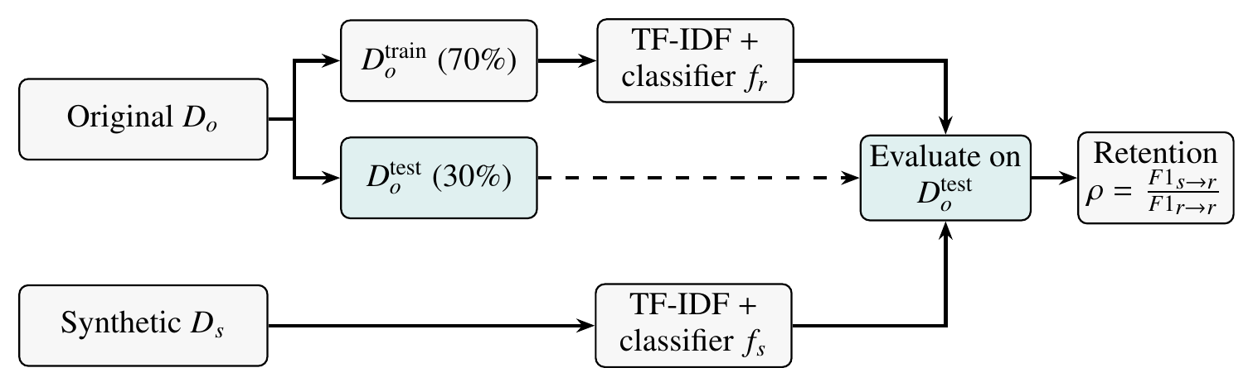
Fig. 2. Controlled utility protocol. The original data are split once (stratified, fixed seed); the real-trained model $f_{r}$ and the synthetic-trained model $f_{s}$ use the same vectorizer and classifier family and are both scored on the identical real test split, which is never used for training.
Downstream utility is evaluated using a controlled experiment, illustrated in Fig. 2. First, a classifier is trained on the real training data and tested on a held-out real test set. The same model configuration is then trained on synthetic training data and evaluated on the identical real test set. This produces a direct estimate of how useful synthetic data is for approximating the original task. The baseline implementation uses TF-IDF features with conventional linear classification models, with accuracy, precision, recall, macro-F1, and weighted-F1 recorded.
In Fig. 2, the upper path is the Real$→$Real baseline and the lower path is the Synthetic$→$Real experiment. The dashed arrow emphasizes that the 30% real test split flows only into evaluation. Three classifier families are run in both paths: logistic regression with balanced class weights, a linear support vector machine, and multinomial naive Bayes [18]. For each class $c$ with precision $P_{c}$ and recall $R_{c}$,
$F1_{c}=\frac{2P_{c}R_{c}}{P_{c}+R_{c}}, F1_{macro}=\frac{1}{K}\sum_{c=1}^{K}{F}1_{c},$ (13)
where $K$ is the number of classes [23]. For each model family $k$, the macro-F1 retention is
$ρ_{k}=min​\left(\frac{F1_{macro}^{\left(k\right)}\left(s​→​r\right)}{max\left(F1_{macro}^{\left(k\right)}\left(r​→​r\right),ϵ\right)}, 1.2\right),$ (14)
and the utility score uses the best model, $U_{util}=100⋅min\left(1,\max_{k}ρ_{k}\right)$. Utility retention may exceed 100% when synthetic-trained performance is higher than the real-data baseline; the dashboard normalizes the dimension score to a maximum of 100 while retaining the raw retention value for interpretation.

F. Composite Score
The project-defined composite score combines the three dimensions using weights of 40% fidelity, 30% diversity, and 30% utility:
$S_{overall}=w_{F}F+w_{D}D+w_{U}U_{util},$ (15)
with $\left(w_{F},w_{D},w_{U}\right)=\left(0.4,0.3,0.3\right)$. User-supplied weights are renormalized to sum to one. The score is explicitly a project metric rather than a universal scientific standard. Scores of 80 or more are labeled strong, 60–79 moderate, and below 60 limited alignment, which the dashboard displays as “Needs Review.”

G. Implementation
The user interface was implemented as a research dashboard with five workflow stages: dataset type, original dataset, synthetic dataset, evaluation, and results. The frontend is written in React and TypeScript with Vite, Tailwind CSS for styling, TanStack Query for server-state management, and Recharts for visualizations.
It is built with FastAPI and Pydantic for typed request/response schemas, SQLAlchemy for persistence, pandas and NumPy for data handling, SciPy for the Jensen–Shannon computation, scikit-learn [18] for vectorization and classification, and ReportLab for PDF generation. PostgreSQL is used for experiment storage, with SQLite supported for local development. Experiment configurations record model names, random seeds, sampling parameters, preprocessing settings, metric definitions, and scoring weights to improve reproducibility.
The application deliberately avoids building a synthetic-data generator. The synthetic dataset is treated as an external input so that the framework can evaluate datasets produced by different generation methods without coupling evaluation to a particular generator.

V. Dataset Description and Experimental Setup
A Hindi sentiment-analysis dataset was selected to evaluate the framework. The experiment used three labels—negative, neutral, and positive—and compared the original corpus (labeled Hi-Train in the dashboard) with a synthetic corpus of approximately equal size (Synthetic Hindi Sentiment 2480). Both datasets contained two columns (text and label) and three classes. As shown later in Fig. 5, the label proportions are roughly 30% negative, 28% neutral, and 42% positive in both corpora.
All metrics used the configuration in Section IV, with a stratified 70/30 split of the original data, a fixed random seed, and weights $\left(0.4,0.3,0.3\right)$.

VI. Results and Discussion
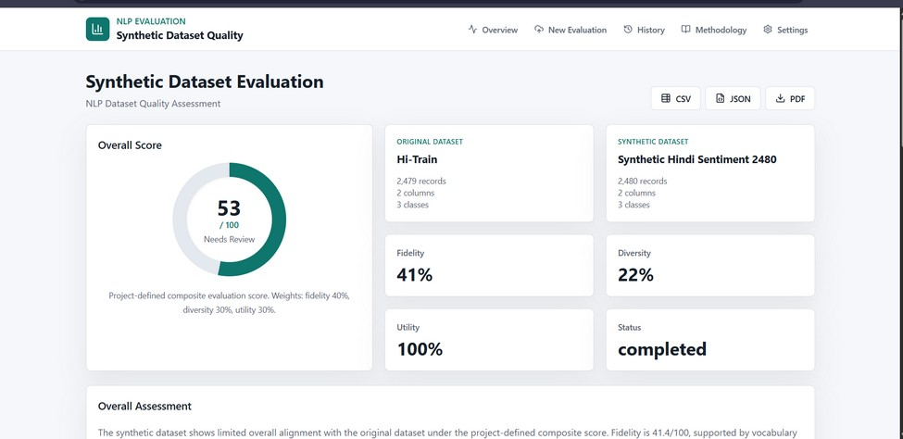
Fig. 3. Evaluation dashboard showing the overall score and the three evaluation dimensions.
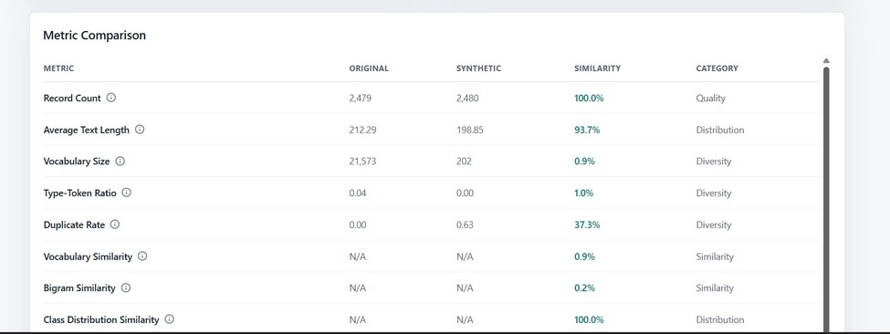
Fig. 4. Metric-level comparison between the original and synthetic Hindi sentiment datasets.

A. Description of the Dashboard Screens
Evaluation dashboard (Fig. 3). The header contains the navigation bar (Overview, New Evaluation, History, Methodology, and Settings) and three export buttons for CSV, JSON, and PDF. The left card shows the overall score as a donut gauge: the filled arc corresponds to 53 out of 100, and the label “Needs Review” reflects the limited-alignment band. The two cards at the top right name the compared datasets. The four smaller cards report the dimension scores—fidelity 41%, diversity 22%, utility 100%—and the run status, completed.
Metric comparison table (Fig. 4). Each row lists one metric with its original value, synthetic value, similarity, and category (quality, distribution, diversity, or similarity). Paired statistics such as record count and text length show both raw values, whereas overlap metrics such as vocabulary and bigram similarity are inherently pairwise and show “N/A” in the value columns.
Assessment and charts (Fig. 5). The Overall Assessment panel contains the automatically generated interpretation. Below it, the Class Distribution chart plots the original (teal) and synthetic (orange) proportions for each label side by side; the bars are almost identical in height. The Dimension Scores chart shows the three scores on a 0–100 scale.

B. Quantitative Results
The results show a clear separation between the evaluation dimensions. The average text length was 212.29 for the original data and 198.85 for the synthetic data, producing a reported similarity of 93.7%. Class-distribution similarity was reported as 100.0%, indicating that the synthetic data reproduced the label proportions closely.
However, lexical diversity was substantially weaker. The original vocabulary contained 21,573 unique tokens compared with 202 in the synthetic dataset. The resulting reported vocabulary similarity was only 0.9%, while bigram similarity was 0.2%. TTR was 0.04 for the original dataset and approximately 0.00 for the synthetic dataset. The duplicate rate increased from approximately 0.00 in the original dataset to 0.63 in the synthetic dataset, corresponding to a low duplicate-rate similarity of 37.3%; in other words, only about 37% of the synthetic records are distinct texts. These results indicate substantial repetition and limited lexical novelty in the synthetic corpus.
The dashboard reported a project-defined fidelity score of 41% (41.4), diversity of 22% (22.42), and a normalized utility score of 100%, producing an overall composite score of 53/100. Substituting into (15) gives $0.4\left(41.4\right)+0.3\left(22.42\right)+0.3\left(100\right)=53.3$, which is displayed as 53. The raw downstream macro-F1 retention was approximately 120%. Thus, the synthetic dataset performed strongly in the selected downstream experiment despite exhibiting weak lexical fidelity and diversity. This is an important result: task utility alone would have overstated the quality of the synthetic corpus.
TABLE I
SUMMARY OF EXPERIMENTAL RESULTS
Metric | Original vs. Synthetic / Result
Record count | 2,479 vs. 2,480 (100.0%)
Mean text length | 212.29 vs. 198.85 (93.7%)
Vocabulary size | 21,573 vs. 202 (0.9%)
Type-token ratio | 0.04 vs. approx. 0.00 (1.0%)
Duplicate rate | approx. 0.00 vs. 0.63 (37.3%)
Bigram similarity | 0.2%
Class-distribution similarity | 100.0%
Fidelity score | 41%
Diversity score | 22%
Utility score | 100% normalized; raw macro-F1 retention approx. 120%
Overall composite | 53 / 100
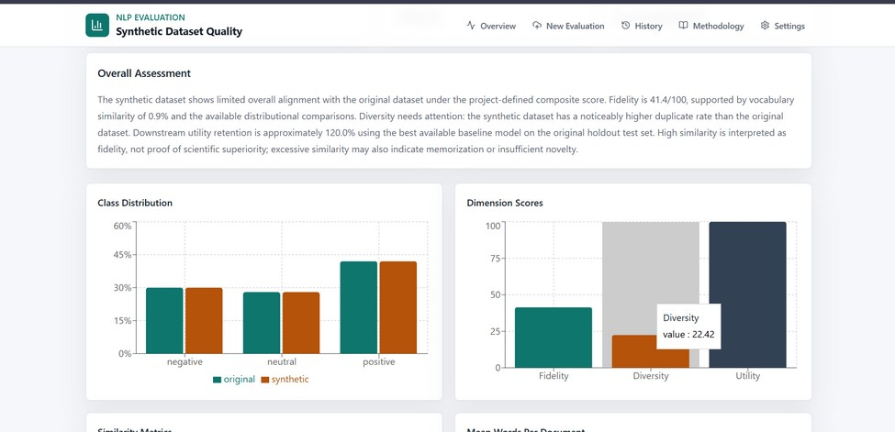
Fig. 5. Overall assessment and dimension scores generated by the evaluation framework.

C. Discussion
The central result is that synthetic-data quality is not one-dimensional. The experiment achieved excellent class-distribution alignment and high downstream utility, but poor vocabulary overlap and diversity. Table I summarizes these values.
The difference between utility and diversity is particularly informative. A classifier can learn the target label boundary from repeated or highly templated examples even when those examples cover only a small portion of the original vocabulary. So the 120% macro-F1 retention does not mean the synthetic data is better than the original; it only shows the synthetic examples were enough for this particular task and setup.
The breakdown of the scores explains why the composite is only moderate. In the fidelity score (9), the class-distribution and length components are close to one, but the three overlap components are close to zero, which pulls the average down to 41.4. In the diversity score (12), the unique-text ratio and $\left(1−R_{dup}\right)$ are both about 0.37 and the synthetic TTR is near zero, which yields 22.42. Only the utility dimension saturates.

VII. Limitations
Several limitations remain. First, the demonstration is based on a single Hindi sentiment dataset and one synthetic dataset, so the findings are not generalizable to all NLP tasks. Second, lexical similarity metrics are sensitive to tokenization and language-specific preprocessing. Third, semantic similarity based on pretrained embeddings depends on the selected embedding model and may not capture every linguistic or cultural nuance of Hindi text.
Fourth, the composite score uses project-defined weights. Although the weighting makes the dashboard easy to interpret, different applications may reasonably assign different importance to fidelity, diversity, and utility. Finally, downstream utility does not constitute a privacy guarantee, and near-duplicate detection is only an indicator of potential overlap rather than a definitive privacy-leakage test.

VIII. Conclusion and Future Work
This work presents a practical, research-oriented framework for evaluating synthetic NLP datasets through three complementary dimensions: fidelity, diversity, and downstream utility. The implemented system provides a consistent workflow for uploading real and synthetic datasets, calculating aligned metrics, running controlled classification experiments, and generating interpretable comparison reports.
The Hindi sentiment evaluation demonstrates the value of the approach. Although the synthetic corpus closely matched class distributions and produced strong downstream utility, its very low vocabulary similarity and high duplicate rate revealed important quality deficiencies that would have been missed by task accuracy alone. The final project-defined score of 53/100 therefore provides a more nuanced assessment than a single predictive metric.
Future work can extend the framework to additional NLP tasks such as topic classification, spam detection, named-entity recognition, and multilingual evaluation. Further research can add stronger privacy-risk analysis, fairness evaluation, human quality assessment, confidence intervals across repeated trials, and comparisons among multiple synthetic-data generation methods. A larger benchmark spanning languages and domains would also enable statistically stronger conclusions.

References
[1] A. Vaswani et al., “Attention is all you need,” in Proc. Adv. Neural Inf. Process. Syst. (NeurIPS), 2017, pp. 5998–6008.
[2] J. Devlin, M.-W. Chang, K. Lee, and K. Toutanova, “BERT: Pre-training of deep bidirectional transformers for language understanding,” in Proc. NAACL-HLT, 2019, pp. 4171–4186.
[3] T. B. Brown et al., “Language models are few-shot learners,” in Proc. Adv. Neural Inf. Process. Syst. (NeurIPS), vol. 33, 2020, pp. 1877–1901.
[4] T. Schick and H. Schütze, “Generating datasets with pretrained language models,” in Proc. EMNLP, 2021, pp. 6943–6951.
[5] Y. Meng, J. Huang, Y. Zhang, and J. Han, “Generating training data with language models: Towards zero-shot language understanding,” in Proc. Adv. Neural Inf. Process. Syst. (NeurIPS), vol. 35, 2022.
[6] Y. Wang et al., “Self-Instruct: Aligning language models with self-generated instructions,” in Proc. ACL, 2023, pp. 13484–13508.
[7] J. Wei and K. Zou, “EDA: Easy data augmentation techniques for boosting performance on text classification tasks,” in Proc. EMNLP-IJCNLP, 2019, pp. 6382–6388.
[8] S. Y. Feng et al., “A survey of data augmentation approaches for NLP,” in Findings of ACL-IJCNLP, 2021, pp. 968–988.
[9] N. Carlini et al., “Extracting training data from large language models,” in Proc. 30th USENIX Security Symp., 2021, pp. 2633–2650.
[10] A. Havrilla et al., “Surveying the effects of quality, diversity, and complexity in synthetic data from large language models,” arXiv preprint arXiv:2412.02980, 2024.
[11] Y. Yu et al., “Large language model as attributed training data generator: A tale of diversity and bias,” in Proc. Adv. Neural Inf. Process. Syst. (NeurIPS) Datasets and Benchmarks Track, vol. 36, 2023.
[12] P. Joshi, S. Santy, A. Budhiraja, K. Bali, and M. Choudhury, “The state and fate of linguistic diversity and inclusion in the NLP world,” in Proc. ACL, 2020, pp. 6282–6293.
[13] D. Kakwani et al., “IndicNLPSuite: Monolingual corpora, evaluation benchmarks and pre-trained multilingual language models for Indian languages,” in Findings of EMNLP, 2020, pp. 4948–4961.
[14] M. Doshi and P. Bhattacharyya, “Synthetic data for multilingual NLP: A survey,” CFILT, Indian Institute of Technology Bombay, 2024.
[15] K. Ramesh et al., “SynthTextEval: Synthetic text data generation and evaluation for high-stakes domains,” arXiv preprint arXiv:2507.07229, 2025.
[16] A. Alaa, B. van Breugel, E. S. Saveliev, and M. van der Schaar, “How faithful is your synthetic data? Sample-level metrics for evaluating and auditing generative models,” in Proc. 39th Int. Conf. Mach. Learn. (ICML), PMLR vol. 162, 2022, pp. 290–306.
[17] G. Salton and C. Buckley, “Term-weighting approaches in automatic text retrieval,” Inf. Process. Manage., vol. 24, no. 5, pp. 513–523, 1988.
[18] F. Pedregosa et al., “Scikit-learn: Machine learning in Python,” J. Mach. Learn. Res., vol. 12, pp. 2825–2830, 2011.
[19] P. Jaccard, “The distribution of the flora in the alpine zone,” New Phytologist, vol. 11, no. 2, pp. 37–50, 1912.
[20] J. Lin, “Divergence measures based on the Shannon entropy,” IEEE Trans. Inf. Theory, vol. 37, no. 1, pp. 145–151, 1991.
[21] N. Reimers and I. Gurevych, “Sentence-BERT: Sentence embeddings using Siamese BERT-networks,” in Proc. EMNLP-IJCNLP, 2019, pp. 3982–3992.
[22] K. Lee et al., “Deduplicating training data makes language models better,” in Proc. ACL, 2022, pp. 8424–8445.
[23] M. Sokolova and G. Lapalme, “A systematic analysis of performance measures for classification tasks,” Inf. Process. Manage., vol. 45, no. 4, pp. 427–437, 2009.

